**Dictionaries**

Dictionary is one of the important Data Structures that is usually used to store data in the key-value format. Each element presents in a dictionary data structure compulsorily have a key and some value is associated with that particular key. In other words, we can also say that Dictionary data structure is used to store the data in key-value pairs. Other names for the Dictionary data structure are associative array, map, symbol table but broadly it is referred to as Dictionary.

Dictionaries

A dictionary is a collection of key-value pairs in which the value is accessed by its associated key. For example, the words in the sentence “row, row, row your boat” could be put into a dictionary like the one below:

A collection of key-value pairs (decided by a hash function) in which the value is accessed via the associated key

* + Not stored in an order
  + General purpose
* **Uses**
  + Information retrieval
  + Add, retrieve and update data
  + Run-length encoding
* **Example**
  + “The green, green grass grows”
  + { ‘grass’ : 1, ‘green’ : 2, ‘grows’ : 3, ‘the’ : 4 }
  + 42213 (ignoring letter case)

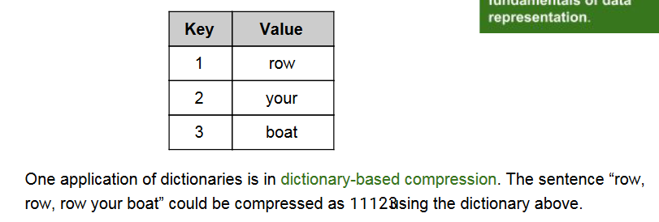

Dictionaries typically support different operations:

* retrieve a value (depending on language, attempting to retrieve a missing key may give a default value or throw an exception)
* insert or update a value (typically, if the key does not exist in the dictionary, the key-value pair is inserted; if the key already exists, its corresponding value is overwritten with the new one)
* remove a key-value pair
* test for existence of a key

